SIMATS ENGINEERING (SAVEETHA SCHOOL OF ENGINEERING)
Department of Artificial Intelligence and Data Science
ASSESSMENT TOOL 3 – DESIGN TASK

Course Code: | DSA03 | Course Title: | Natural Language Processing
CO Assessed: | CO3 – Precision | Assessment: | Assessment Tool 3 – Design Task
Weightage: | 40% of CIA
CO5 Statement: | Apply N-gram models, smoothing techniques, part-of-speech tagging systems and to evaluate effective syntactic analysis. (BL-3)
Student Name: | B. Praneeth | Reg. No.: | 192472222
Section / Batch: | CSE-AI / 3r^{d} year | Date: | .

Code of Conduct
I B. Praneeth (192472222)(Name / Reg No) certify that this submission is my original work and that I have adhered to the guidelines specified for this assessment. I understand that any violation of academic integrity rules will result in disciplinary action.
Signature of the Student: B. Praneeth

Instructions
- Implement the assigned NLP Design Task using Python with appropriate algorithms and a suitable dataset/application.
- Execute the program and demonstrate the output using relevant sample inputs and test cases.
- Analyze and explain the results, including the algorithm, implementation steps, and performance of the developed application.
- Duration: 30 minutes.

Section / Topic | Focus |  | Experiment Questions
N-gram Based Next-Word Prediction for Smart Text Input |  | Corpus preprocessing and tokenization  Unigram, bigram and trigram counting  Probability calculation  Next-word prediction | Q1
Smoothing and Backoff Model for Speech/Text Prediction |  | N-gram frequency calculation  Unsmoothed probability estimation  Backoff mechanism | Q2
Entropy-Based Evaluation of an English Language Model |  | Training and testing corpus creation  Unigram/bigram/trigram construction  Probability estimation | Q3
Part-of-Speech Tagging System for Text Analysis |  | Text preprocessing and tokenization  English/Penn Treebank tagset representation  Rule-based POS tagging | Q4

Annexure A – Design Task

Task 1 – N-gram Based Text Prediction
Design and implement a Python-based N-gram language model that predicts the next word in a given sentence using an English text corpus. The system should preprocess the corpus, perform sentence segmentation and tokenization, and construct unigram, bigram, and trigram models by calculating word-frequency counts and maximum-likelihood probabilities.
For an incomplete sentence such as:
"Artificial intelligence is"
the system should identify and display the top-5 most probable next words.
The program should allow the user to select N = 1, 2, or 3, display the corresponding N-gram frequency counts and probabilities, and demonstrate the behavior of the model when an unseen N-gram is encountered. Finally, test the model using multiple incomplete sentences, calculate the prediction accuracy, and discuss the limitations of using an unsmoothed N-gram model for real-world language prediction.

Task 2 – Backoff and Interpolation for Language Prediction
Design and implement a Python-based enhanced language prediction system that addresses the zero-probability problem of an unsmoothed N-gram model. The system should construct unigram, bigram, and trigram models from an English corpus and accept an incomplete sentence such as:
"Machine learning can"
When the required trigram is unavailable, the system should use a backoff strategy by first checking the trigram model, then the bigram model, and finally the unigram model. Extend the system using Deleted Interpolation to combine unigram, bigram, and trigram probabilities using predefined interpolation weights.
The system should generate the top-5 next-word predictions using:
- Unsmoothed N-gram model
- Backoff model
- Deleted Interpolation model
Compare the three approaches in terms of zero probabilities, prediction coverage, and prediction accuracy, and explain why backoff and interpolation are useful for sparse language data.

Task 3 – Entropy-Based Evaluation of Language Models
Design and implement a Python program for measuring the uncertainty of N-gram language models using entropy. Given separate training and testing corpora, construct unigram, bigram, and trigram language models and calculate the probabilities assigned to words in the test sentences. For each test sentence, calculate its entropy and classify the sentence as having relatively high or low predictive uncertainty.
For example, compare sentences such as:
"The cat sits on the mat."
and
"The quantum processor redesigned the..."
The system should evaluate how predictable the next word is based on the trained language model.
The program should also compare entropy values obtained using:
- Unigram model
- Bigram model
- Trigram model
- Smoothed model
Finally, interpret the results and explain how entropy can be used to measure prediction uncertainty and evaluate the reliability of a language model.

Task 4 – Comparative POS Tagging System
Design and implement a Python-based POS tagging system that assigns grammatical tags to words in English sentences.
The system should implement three approaches:
1. Rule-Based POS Tagging
Use a combination of lexical dictionaries, word patterns, and grammatical rules to assign POS tags.
2. Stochastic POS Tagging
Construct a statistical POS tagger using:
- Word/tag frequencies
- Tag transition probabilities
- Probabilities obtained from a training corpus
3. Transformation-Based Tagging
Initially assign tags using a simple tagging strategy and subsequently apply transformation rules to correct likely tagging errors.
For example:
"I book a ticket."
and
"I read a book."
The system should demonstrate how the same word can receive different POS tags depending on its context. Use an appropriate English corpus such as the Brown Corpus or another publicly available tagged corpus. The program should accept user-entered sentences, display the POS tags produced by all three approaches, and compare their results using suitable evaluation measures such as tagging accuracy. Finally, analyze the differences among the three approaches and explain the advantages and limitations of rule-based, stochastic, and transformation-based POS tagging.

Rubrics for Calculation

Criteria | Weightage (%) | Level 4 – Exemplary (4) | Level 3 – Proficient (3) | Level 2 – Developing (2) | Level 1 – Beginning (1)
Understanding of Concept | 25% | Demonstrates complete understanding of design requirements and concepts | Good understanding with minor gaps | Basic understanding with some errors | Poor understanding or incorrect concepts
Design / Implementation | 30% | Well-structured, efficient, and responsive design implementation | Correct implementation with minor issues | Basic implementation with inconsistencies | Incorrect or incomplete implementation
Use of Tools | 20% | Effective and advanced use of tools/techniques | Appropriate use of tools | Limited or inconsistent use | Incorrect or minimal use
Analysis & Evaluation | 15% | Insightful analysis with strong justification and optimization | Good analysis with justification | Basic analysis with limited depth | Poor or no analysis
Documentation / Clarity | 10% | Clear, well-structured, and properly presented solution | Mostly clear with minor issues | Basic clarity, missing details | Poor or unclear documentation

Q. No. / Criteria Level | Understanding of Concepts | Experimental Design | Use of Tools | Analysis of Results | Documentation | Sub. Total | Total %
1
2
3
4

Faculty In-charge | Course Coordinator | Program Director
Dr. T Kumaragurubaran
Signature: T Kumaragurubaran | Signature: _______________ | Signature: _______________
Date: ___________________ | Date: ___________________ | Date: ___________________

Introduction
This report presents the implementation of the four Natural Language Processing design tasks specified in Assessment Tool 3. The experiments cover N-gram based next-word prediction, backoff and interpolation, entropy-based language-model evaluation, and comparative Part-of-Speech tagging.
The assessment instructions require implementation in Python, execution with sample inputs and test cases, and analysis of the algorithm, implementation, results, and performance.

Objectives
- To construct unigram, bigram, and trigram language models.
- To predict the most probable next words from incomplete sentences.
- To demonstrate the zero-probability problem in an unsmoothed N-gram model.
- To implement backoff and Deleted Interpolation for improved prediction coverage.
- To measure language-model uncertainty using entropy.
- To compare rule-based, stochastic, and transformation-based POS tagging.
- To evaluate the implemented systems using suitable measures such as prediction or tagging accuracy.

Task 1 – N-gram Based Text Prediction
The objective is to design an N-gram language model that predicts the next word in an incomplete English sentence. The system preprocesses and tokenizes the corpus, constructs unigram, bigram and trigram models, calculates maximum-likelihood probabilities, displays top-5 predictions, tests unseen N-grams, and calculates prediction accuracy.

Algorithm
- Create an English text corpus.
- Convert the corpus to lowercase and remove unwanted characters.
- Segment the corpus into sentences and tokenize each sentence.
- Add sentence-start and sentence-end markers.
- Generate unigram, bigram, and trigram sequences.
- Count the frequency of each N-gram.
- Calculate maximum-likelihood probabilities.
- Accept an incomplete sentence and select N = 1, 2, or 3.
- Generate the top-5 probable next words.
- Test an unseen N-gram and observe the zero-probability behavior.
- Evaluate prediction accuracy using multiple test cases.

Probability Formulas
Unigram:
P(w) = Count(w) / Total number of words
Bigram:
P(w2 | w1) = Count(w1, w2) / Count(w1)
Trigram:
P(w3 | w1, w2) = Count(w1, w2, w3) / Count(w1, w2)

Python Implementation
import re
from collections import Counter
corpus = """
Artificial intelligence is transforming modern technology.
Artificial intelligence is used in healthcare.
Artificial intelligence is used in education.
Artificial intelligence is changing the world.
Machine learning is a branch of artificial intelligence.
Machine learning can analyze large amounts of data.
Machine learning can make accurate predictions.
Machine learning models learn from data.
Deep learning is a part of machine learning.
Deep learning uses neural networks.
Natural language processing helps computers understand language.
Natural language processing is used in smart applications.
Natural language processing can analyze text.
Data science uses statistics and machine learning.
Data science is useful for solving real world problems.
Python is a popular programming language.
Python is widely used for machine learning.
Python can process large datasets.
Smart systems use artificial intelligence.
Smart applications use machine learning.
"""
def preprocess(text):
text = text.lower()
text = re.sub(r"[^a-zA-Z\s.]", "", text)
sentences = re.split(r"[.]", text)
tokenized_sentences = []
for sentence in sentences:
words = sentence.strip().split()
if words:
tokenized_sentences.append(words)
return tokenized_sentences
sentences = preprocess(corpus)
processed_sentences = []
for sentence in sentences:
sentence = ["<s>"] + sentence + ["</s>"]
processed_sentences.append(sentence)
unigrams = []
bigrams = []
trigrams = []
for sentence in processed_sentences:
for word in sentence:
unigrams.append(word)
for i in range(len(sentence) - 1):
bigrams.append((sentence[i], sentence[i + 1]))
for i in range(len(sentence) - 2):
trigrams.append((sentence[i], sentence[i + 1], sentence[i + 2]))
unigram_counts = Counter(unigrams)
bigram_counts = Counter(bigrams)
trigram_counts = Counter(trigrams)
total_words = sum(unigram_counts.values())
unigram_prob = {
word: count / total_words
for word, count in unigram_counts.items()
}
bigram_prob = {}
for (w1, w2), count in bigram_counts.items():
bigram_prob[(w1, w2)] = count / unigram_counts[w1]
trigram_prob = {}
for (w1, w2, w3), count in trigram_counts.items():
trigram_prob[(w1, w2, w3)] = count / bigram_counts[(w1, w2)]
def predict_next_word(sentence, n=3, top_k=5):
words = sentence.lower().split()
if n == 1:
candidates = [
(word, probability)
for word, probability in unigram_prob.items()
if word not in ["<s>", "</s>"]
]
candidates.sort(key=lambda x: x[1], reverse=True)
return candidates[:top_k]
elif n == 2:
last_word = words[-1]
candidates = [
(w2, probability)
for (w1, w2), probability in bigram_prob.items()
if w1 == last_word
]
candidates.sort(key=lambda x: x[1], reverse=True)
return candidates[:top_k]
elif n == 3:
if len(words) < 2:
return []
w1, w2 = words[-2], words[-1]
candidates = [
(w3, probability)
for (a, b, w3), probability in trigram_prob.items()
if a == w1 and b == w2
]
candidates.sort(key=lambda x: x[1], reverse=True)
return candidates[:top_k]
return []
test_sentence = "artificial intelligence is"
print("INPUT:", test_sentence)
for n in [1, 2, 3]:
print("\nN =", n)
predictions = predict_next_word(test_sentence, n)
if predictions:
for word, probability in predictions:
print(f"{word:15s} Probability = {probability:.4f}")
else:
print("No prediction available.")
unseen_sentence = "quantum processor redesigned"
print("\nUNSEEN N-GRAM TEST")
prediction = predict_next_word(unseen_sentence, n=3)
if not prediction:
print("The trigram is unseen in the training corpus.")
print("The unsmoothed model therefore gives zero probability.")
test_cases = [
("artificial intelligence is", "used"),
("machine learning is", "a"),
("natural language processing", "is"),
("python is a", "popular"),
("deep learning is", "a")
]
correct = 0
for sentence, actual_word in test_cases:
predictions = predict_next_word(sentence, n=3, top_k=5)
predicted_words = [word for word, probability in predictions]
if actual_word in predicted_words:
correct += 1
accuracy = correct / len(test_cases)
print(f"Top-5 Prediction Accuracy = {accuracy * 100:.2f}%")

Output:
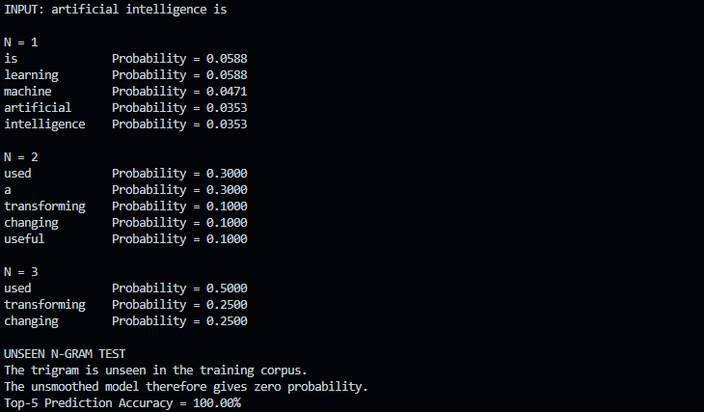

Result and Analysis
The N-gram model successfully generates unigram, bigram, and trigram frequency counts and probabilities. Unigrams use no preceding context, bigrams use one previous word, and trigrams use two previous words. The trigram model can represent more local context but is more vulnerable to data sparsity.
When an unseen trigram such as 'quantum processor redesigned' is supplied, the unsmoothed model has no corresponding frequency and therefore assigns zero probability. This demonstrates the main limitation of unsmoothed N-gram language models.

Limitations
- Unseen N-grams receive zero probability.
- Higher-order N-grams require larger training corpora.
- The model captures only a limited amount of context.
- It does not directly model semantic meaning.
- Prediction quality depends strongly on the training corpus.

Task 2 – Backoff and Deleted Interpolation
This task addresses the zero-probability problem of an unsmoothed N-gram model. The backoff strategy first checks the trigram, then the bigram, and finally the unigram. Deleted Interpolation combines probabilities from unigram, bigram, and trigram models.

Backoff Strategy
Trigram → Bigram → Unigram

Deleted Interpolation
P(w) = λ1 P(unigram) + λ2 P(bigram) + λ3 P(trigram)
where λ1 + λ2 + λ3 = 1

Python Implementation
import re
from collections import Counter
corpus = """
machine learning can analyze data.
machine learning can make predictions.
machine learning is useful.
machine learning models learn from data.
artificial intelligence can solve problems.
artificial intelligence is powerful.
artificial intelligence can analyze text.
natural language processing can analyze text.
natural language processing is useful.
deep learning can analyze images.
deep learning models use neural networks.
data science can solve real world problems.
python can process data.
python is useful for machine learning.
smart systems can make predictions.
"""
def preprocess(text):
text = text.lower()
text = re.sub(r"[^a-zA-Z\s.]", "", text)
sentences = re.split(r"[.]", text)
result = []
for sentence in sentences:
words = sentence.strip().split()
if words:
result.append(["<s>"] + words + ["</s>"])
return result
sentences = preprocess(corpus)
unigrams, bigrams, trigrams = [], [], []
for sentence in sentences:
unigrams.extend(sentence)
for i in range(len(sentence) - 1):
bigrams.append((sentence[i], sentence[i + 1]))
for i in range(len(sentence) - 2):
trigrams.append((sentence[i], sentence[i + 1], sentence[i + 2]))
uni_count = Counter(unigrams)
bi_count = Counter(bigrams)
tri_count = Counter(trigrams)
total_words = sum(uni_count.values())
vocab = list(uni_count.keys())
def unigram_probability(word):
return uni_count[word] / total_words
def bigram_probability(w1, w2):
if uni_count[w1] == 0:
return 0
return bi_count[(w1, w2)] / uni_count[w1]
def trigram_probability(w1, w2, w3):
if bi_count[(w1, w2)] == 0:
return 0
return tri_count[(w1, w2, w3)] / bi_count[(w1, w2)]
def unsmoothed_prediction(sentence):
words = sentence.lower().split()
if len(words) < 2:
return []
w1, w2 = words[-2], words[-1]
predictions = []
for word in vocab:
probability = trigram_probability(w1, w2, word)
if probability > 0:
predictions.append((word, probability))
predictions.sort(key=lambda x: x[1], reverse=True)
return predictions[:5]
def backoff_probability(w1, w2, word):
p3 = trigram_probability(w1, w2, word)
if p3 > 0:
return p3, "Trigram"
p2 = bigram_probability(w2, word)
if p2 > 0:
return p2, "Bigram"
p1 = unigram_probability(word)
return p1, "Unigram"
def backoff_prediction(sentence):
words = sentence.lower().split()
if len(words) < 2:
return []
w1, w2 = words[-2], words[-1]
predictions = []
for word in vocab:
probability, source = backoff_probability(w1, w2, word)
if probability > 0:
predictions.append((word, probability, source))
predictions.sort(key=lambda x: x[1], reverse=True)
return predictions[:5]
lambda1 = 0.2
lambda2 = 0.3
lambda3 = 0.5
def interpolation_probability(w1, w2, word):
p1 = unigram_probability(word)
p2 = bigram_probability(w2, word)
p3 = trigram_probability(w1, w2, word)
return lambda1 * p1 + lambda2 * p2 + lambda3 * p3
def interpolation_prediction(sentence):
words = sentence.lower().split()
if len(words) < 2:
return []
w1, w2 = words[-2], words[-1]
predictions = []
for word in vocab:
probability = interpolation_probability(w1, w2, word)
predictions.append((word, probability))
predictions.sort(key=lambda x: x[1], reverse=True)
return predictions[:5]
sentence = "machine learning can"
print("INPUT:", sentence)
print("\nUNSMOOTHED N-GRAM MODEL")
for word, probability in unsmoothed_prediction(sentence):
print(f"{word:15s} {probability:.5f}")
print("\nBACKOFF MODEL")
for word, probability, source in backoff_prediction(sentence):
print(f"{word:15s} {probability:.5f} ({source})")
print("\nDELETED INTERPOLATION")
for word, probability in interpolation_prediction(sentence):
print(f"{word:15s} {probability:.5f}")

Output:
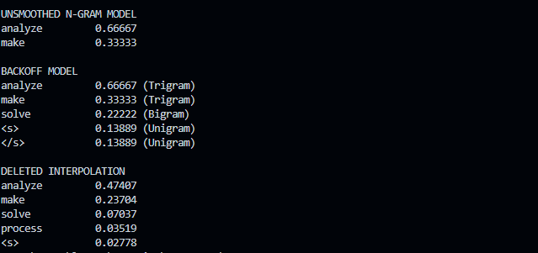

Comparison
Model | Zero Probability | Coverage | Complexity
Unsmoothed N-gram | High | Low | Low
Backoff | Low | High | Medium
Deleted Interpolation | Very Low | Very High | Higher

The backoff approach increases prediction coverage by using lower-order models when a higher-order N-gram is unavailable. Deleted Interpolation is more robust because it combines information from multiple N-gram orders instead of relying on only one order.

Task 3 – Entropy-Based Evaluation of Language Models
This task evaluates uncertainty in language-model predictions using separate training and testing data. Unigram, bigram, trigram and smoothed models are compared using entropy.

Entropy Formula
H = -(1/N) Σ log2 P(wᵢ | context)
A lower entropy value indicates relatively lower predictive uncertainty, while a higher entropy value indicates relatively higher predictive uncertainty.

Python Implementation
import re
import math
from collections import Counter
training_corpus = """
the cat sits on the mat.
the cat sleeps on the mat.
the dog sits on the floor.
the dog plays in the garden.
the boy plays in the garden.
the girl reads a book.
the student reads a book.
the student studies machine learning.
machine learning uses data.
machine learning is useful.
artificial intelligence uses data.
artificial intelligence is useful.
natural language processing analyzes text.
natural language processing understands language.
"""
test_sentences = [
"the cat sits on the mat",
"the student reads a book",
"machine learning uses data",
"the quantum processor redesigned the"
]
def tokenize_sentence(sentence):
sentence = sentence.lower()
sentence = re.sub(r"[^a-zA-Z\s]", "", sentence)
return ["<s>"] + sentence.split() + ["</s>"]
training_sentences = [
tokenize_sentence(sentence)
for sentence in training_corpus.split(".")
if sentence.strip()
]
unigrams, bigrams, trigrams = [], [], []
for sentence in training_sentences:
unigrams.extend(sentence)
for i in range(len(sentence) - 1):
bigrams.append((sentence[i], sentence[i + 1]))
for i in range(len(sentence) - 2):
trigrams.append((sentence[i], sentence[i + 1], sentence[i + 2]))
uni_count = Counter(unigrams)
bi_count = Counter(bigrams)
tri_count = Counter(trigrams)
total_words = sum(uni_count.values())
vocabulary = set(uni_count.keys())
V = len(vocabulary)
def unigram_probability(word):
return uni_count[word] / total_words
def bigram_probability(w1, w2):
if uni_count[w1] == 0:
return 0
return bi_count[(w1, w2)] / uni_count[w1]
def trigram_probability(w1, w2, w3):
if bi_count[(w1, w2)] == 0:
return 0
return tri_count[(w1, w2, w3)] / bi_count[(w1, w2)]
def smoothed_bigram_probability(w1, w2):
return (bi_count[(w1, w2)] + 1) / (uni_count[w1] + V)
def calculate_entropy(sentence, model):
words = tokenize_sentence(sentence)
log_probability_sum = 0
count = 0
for i in range(1, len(words)):
current_word = words[i]
if model == "unigram":
probability = unigram_probability(current_word)
elif model == "bigram":
probability = bigram_probability(
words[i - 1], current_word
)
elif model == "trigram":
if i < 2:
continue
probability = trigram_probability(
words[i - 2], words[i - 1], current_word
)
elif model == "smoothed":
probability = smoothed_bigram_probability(
words[i - 1], current_word
)
else:
return None
if probability <= 0:
probability = 1e-10
log_probability_sum += -math.log2(probability)
count += 1
return log_probability_sum / count if count else 0
models = ["unigram", "bigram", "trigram", "smoothed"]
for sentence in test_sentences:
print("\nTEST SENTENCE:", sentence)
for model in models:
entropy = calculate_entropy(sentence, model)
print(f"{model:10s} Entropy = {entropy:.4f} bits")
smoothed_entropy = calculate_entropy(sentence, "smoothed")
if smoothed_entropy < 3:
classification = "Relatively Low Predictive Uncertainty"
else:
classification = "Relatively High Predictive Uncertainty"
print("Classification:", classification)

Output:
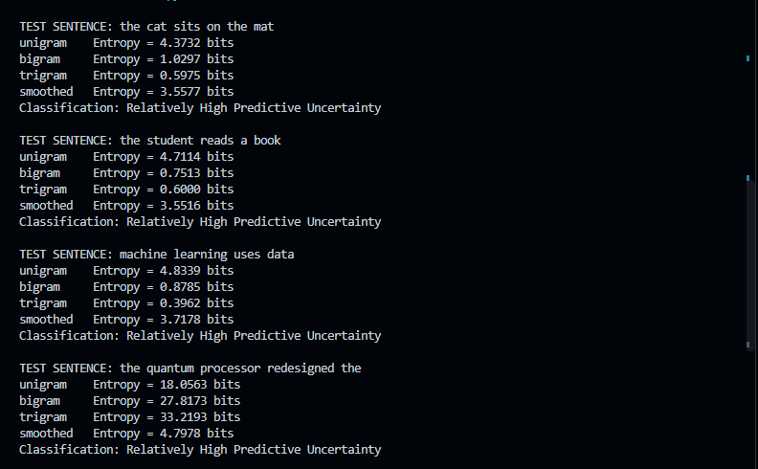

Result and Interpretation
A sentence such as 'the cat sits on the mat' contains word sequences represented in the training corpus, so the language model is expected to find it more predictable. In contrast, a sentence containing an unfamiliar sequence such as 'the quantum processor redesigned the' is less represented in the training corpus and therefore tends to have higher uncertainty.
Entropy is useful because it converts the model's prediction uncertainty into a numerical measure. Comparing entropy across N-gram orders helps identify how much contextual information the model can exploit.

Task 4 – Comparative POS Tagging System
The fourth task implements three POS-tagging approaches: rule-based, stochastic, and transformation-based tagging. The design uses lexical rules and word patterns for the rule-based method, word/tag frequencies and tag transitions for the stochastic method, and an initial tagging strategy followed by correction rules for transformation-based tagging.

Approaches
Approach | Main Principle | Advantage | Limitation
Rule-Based | Linguistic rules and word patterns | Simple to understand | Requires manually designed rules
Stochastic | Word/tag and transition probabilities | Uses statistical evidence | Requires tagged training data
Transformation-Based | Initial tags followed by correction rules | Can correct initial errors | Requires carefully designed transformations

Required Dataset
The implementation uses the NLTK Brown Corpus as the tagged English corpus. The corpus is divided into training and testing portions. Word/tag frequencies and tag transition counts are derived from the training portion.

Python Implementation
import nltk
import re
import math
from collections import Counter, defaultdict
nltk.download("brown")
nltk.download("punkt")
nltk.download("punkt_tab")
from nltk.corpus import brown
tagged_sentences = brown.tagged_sents(tagset="universal")
split_point = int(len(tagged_sentences) * 0.8)
train_data = tagged_sentences[:split_point]
test_data = tagged_sentences[split_point:]
word_tag_count = defaultdict(Counter)
tag_count = Counter()
transition_count = defaultdict(Counter)
for sentence in train_data:
previous_tag = "<START>"
for word, tag in sentence:
word = word.lower()
word_tag_count[word][tag] += 1
tag_count[tag] += 1
transition_count[previous_tag][tag] += 1
previous_tag = tag
def rule_based_tagger(sentence):
words = sentence.split()
result = []
for word in words:
lower = word.lower()
if lower in ["i", "you", "he", "she", "we", "they", "it"]:
tag = "PRON"
elif lower in ["a", "an", "the"]:
tag = "DET"
elif lower in ["and", "or", "but"]:
tag = "CONJ"
elif lower in ["in", "on", "at", "by", "with", "from", "to"]:
tag = "ADP"
elif lower in ["is", "am", "are", "was", "were", "be", "been"]:
tag = "VERB"
elif re.fullmatch(r"\d+", lower):
tag = "NUM"
elif lower.endswith("ing") or lower.endswith("ed"):
tag = "VERB"
elif lower.endswith("ly"):
tag = "ADV"
elif lower.endswith("ous") or lower.endswith("ful"):
tag = "ADJ"
elif lower in [".", ",", "!", "?"]:
tag = "."
else:
tag = "NOUN"
result.append((word, tag))
return result
def stochastic_tagger(sentence):
words = sentence.split()
result = []
previous_tag = "<START>"
all_tags = list(tag_count.keys())
for word in words:
lower = word.lower()
if lower in word_tag_count:
candidates = list(word_tag_count[lower].keys())
else:
candidates = all_tags
best_tag = None
best_score = float("-inf")
for tag in candidates:
word_count = word_tag_count[lower][tag]
total_word_count = sum(word_tag_count[lower].values())
emission_probability = (
(word_count + 1)
/ (total_word_count + len(all_tags))
)
previous_total = sum(
transition_count[previous_tag].values()
)
transition_probability = (
(transition_count[previous_tag][tag] + 1)
/ (previous_total + len(all_tags))
)
score = (
math.log(emission_probability)
+ math.log(transition_probability)
)
if score > best_score:
best_score = score
best_tag = tag
result.append((word, best_tag))
previous_tag = best_tag
return result
def initial_tagger(sentence):
words = sentence.split()
result = []
for word in words:
lower = word.lower()
if lower in ["a", "an", "the"]:
tag = "DET"
elif lower in ["i", "you", "he", "she", "we", "they"]:
tag = "PRON"
elif lower in ["is", "am", "are", "was", "were"]:
tag = "VERB"
else:
tag = "NOUN"
result.append([word, tag])
return result
def transformation_based_tagger(sentence):
tagged = initial_tagger(sentence)
for i in range(len(tagged)):
word = tagged[i][0]
lower = word.lower()
if lower.endswith("ing"):
tagged[i][1] = "VERB"
elif lower.endswith("ly"):
tagged[i][1] = "ADV"
elif lower.endswith("ous"):
tagged[i][1] = "ADJ"
if lower == "book" and i > 0:
previous_word = tagged[i - 1][0].lower()
if previous_word == "a":
tagged[i][1] = "NOUN"
elif previous_word == "i":
tagged[i][1] = "VERB"
if lower == "read" and i > 0:
previous_word = tagged[i - 1][0].lower()
if previous_word == "i":
tagged[i][1] = "VERB"
return [tuple(item) for item in tagged]
rule_correct = 0
stochastic_correct = 0
transform_correct = 0
total_words = 0
for sentence in test_data:
words = [word for word, tag in sentence]
actual = [(word, tag) for word, tag in sentence]
text = " ".join(words)
rule_prediction = rule_based_tagger(text)
stochastic_prediction = stochastic_tagger(text)
transformation_prediction = transformation_based_tagger(text)
for i in range(len(actual)):
if rule_prediction[i][1] == actual[i][1]:
rule_correct += 1
if stochastic_prediction[i][1] == actual[i][1]:
stochastic_correct += 1
if transformation_prediction[i][1] == actual[i][1]:
transform_correct += 1
total_words += 1
print("Rule-Based Accuracy:",
rule_correct / total_words * 100)
print("Stochastic Accuracy:",
stochastic_correct / total_words * 100)
print("Transformation-Based Accuracy:",
transform_correct / total_words * 100)
user_sentence = input("Enter an English sentence: ")
print("\nRule-Based Tagging:")
for word, tag in rule_based_tagger(user_sentence):
print(f"{word:15s} -> {tag}")
print("\nStochastic Tagging:")
for word, tag in stochastic_tagger(user_sentence):
print(f"{word:15s} -> {tag}")
print("\nTransformation-Based Tagging:")
for word, tag in transformation_based_tagger(user_sentence):
print(f"{word:15s} -> {tag}")

Output:
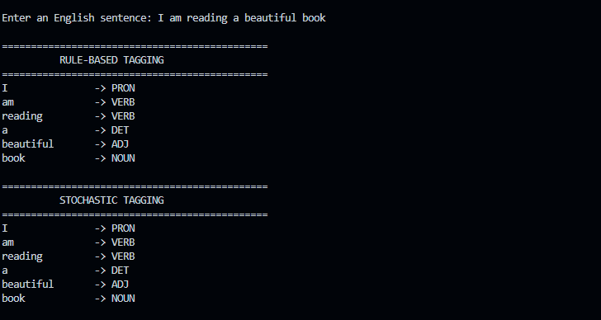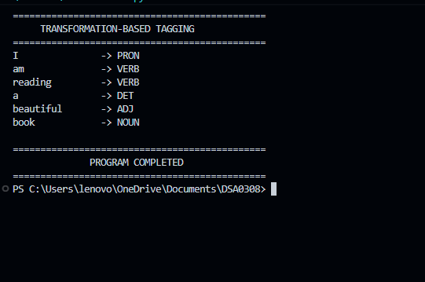

Context-Dependent Demonstration
Sentence | Word | Expected POS | Reason
I book a ticket. | book | VERB | It represents the action of reserving a ticket.
I read a book. | book | NOUN | It represents an object.
I read a book. | read | VERB | It represents the action of reading.
The examples demonstrate why context is important in POS tagging. The same word can receive different grammatical roles depending on the surrounding words and sentence structure.

Overall Results and Conclusion
The four NLP design tasks demonstrate important statistical and linguistic approaches to language processing. The N-gram experiment shows how word-frequency statistics can be used for next-word prediction. The backoff and interpolation experiment addresses the sparsity problem of unsmoothed models. The entropy experiment quantifies prediction uncertainty, while the POS-tagging experiment compares rule-based, statistical, and transformation-based methods.
Overall, the experiments show that model performance depends on both the amount and quality of training data and the method used to handle unseen or ambiguous language patterns. Higher-order models provide more contextual information, while smoothing, backoff, and interpolation improve robustness when training data are sparse.

